E-Healthcare System

CSE471

Submitted to:

Arnisha Khondaker.

Lecturer

Mohshi Masnad,

Lecturer

Department of Computer Science and Engineering

Group Number: 02

Group Members:

|  |  |
| --- | --- |
| Student ID | Student Name |
| 15101065 | Hasan Al Mamun |
| 16301217 | Md. Tamjid Hossain |
| 16101137 | Sajib Mohajan |
| 16101023 | Mohammad Rasheduzzaman Patwary |
| 16301171 | Akash Chandra Paul |

# Introduction

Online healthcare service is an all-new way to provide consultations by medical experts. In simple words, you can just take an online subscription plan from a website and avail medical consultations by virtual means including, video calls, emails or texts.

Keeping track of all the activities and their records on paper is very cumbersome and economically prone. It is also inefficient and a time-consuming process. Recording, maintaining all these records is highly unreliable, inefficient, and error prone. It is also not economically and technically feasible to maintain these records on paper.

Online healthcare service is an all-new way to provide consultations by medical experts. In simple words, you can just take an online subscription plan from a website and avail medical consultations by virtual means.

The E-Health Care System can be entered using a username and password. It is accessible either by an administrator. Only they can add data into the database. The data can be retrieved easily. Patients can login to their account using their username and password. The data are well protected for personal use and makes the data processing very fast.

# Motivation

The main aim of our project is to provide an online communication between doctors and patients. It also aims at being low cost, reliable and user friendly. The system also provides excellent security of data at every level of user system interaction and also provides robust and reliable storage and backup files.

It is aimed to develop to maintain the day-to-day physical state of patients, their diseases, lists of doctors, report generation, etc. It is designed to achieve the following objectives:

* To computerize all details regarding patient details and doctor details.
* Scheduling appointment of patient with doctors to make it convenient for both.
* Scheduling the services to specialized doctors properly so that facilities provided by doctors are fully utilized in effective manner.
* If the medical store issues to medicine to patients, it should reduce the stock status of the medical store and vice-versa.
* The inventory should be updated automatically whenever a transaction is made.
* The information of the patients should be kept up to date and their record should be kept in the system for historical purposes.

# Methodology

The model-view-controller or MVC is software architecture commonly used for creating web applications or software. In other words, it is a structure for web applications to follow in order to ensure efficiency and consistency. Many of the most popular frameworks use the MVC architecture, including ASP.NET, Code Igniter, Zend, Django, and Ruby on Rails. At the same time, many web developers do not use a coding framework yet still set up their applications to follow the MVC structure.

Without a good reason to use a new structure, framework, technology, or trend, many developers may have a hard time getting motivated to learn a new topic. Therefore, to begin, we will first introduce why the model-view-controller architecture is so important, and why you should begin adopting its practices in your next web application.

A web application or piece of software that follows the MVC structure separates the three main types of functionalities into three types of files: models, views, and controllers. This allows each portion to be designed, implemented, and tested independently from any other one, keeping code organized. Keeping the code organized means being able to find what is needed quickly, test features, correct or alter them quicker, and add new functionality with ease. It also means more efficient code, and a better way to re-use code for faster applications.

Probably one of the greatest benefits however is that it is easy to understand and use the MVC structure for creating web applications. If developers use any of the popular web development frameworks, then they understand and use the MVC structure as well. Because of this consistency, managing a project between several developers can be easier as well.

# Background Study

Telemedicine healthcare platforms are a major boom in the field of healthcare. You can get medical advice at the comfort of sitting at home. Not only for the patients, this platform is quite beneficial for the doctors as well.

For the developing nations, telemedicine is proving to be successful in the end. Since for the people living in distant locations becomes hard to travel long distances for consulting doctors. However, there is still a lot of scope for improvement. For villages located in extreme interiors do not even have phone connection which means to reach them is still a task.

In such nations, there is a huge demand for medical specialists, and to fill that gap telemedicine platform has proved to be beneficial. It is solving some major grey areas for all countries.

For immediate consultations, be it in the middle of the night, you can trust these online portals and get in talking with a medical expert.

One such E-Health Care System in Bangladesh is BdHealthSolution. It is an online clinic providing online consultations and treatments using a remote doctor/patient interface. The BdHealthSolution is one of the most established online Healthcare providers and one of the only a handful licensed by the Bangladesh Health Commission. Their service using is very simple, just massage their website chat box or official Facebook page, a full dedicated Doctors team are waiting for feedback massage in 24 hours without any fee. You just find the Department and make a massage to us. It is simple you just find the consultation that require some basic question to you and you have to complete their question answer. They will ask you few medical question to identify your current disease. Once the answer is submitted, one of their experienced Doctor who operate around the clock 24/7 will review it.

# System Description

## Functional Requirements:

The functionality of a system is measured by how well that system meets the functional requirements of the stockholders. The functional requirements exhibit what the system should do without any regard on how they could be done.

The functional requirements for our E Health System are:

1. The system shall allow its user to update their personal information.
2. The system shall allow the doctor to update patient information.
3. The system shall allow the patient’s primary doctor to schedule appointments for their patients.
4. The system shall allow the patient to review their prescriptions and doctors’ instructions.
5. The system shall generate bills and forward to the patient.

## Non-functional Requirements:

Nonfunctional Requirements represent constraints or quality measures that the system should abide by. They depict some quality attributes that the home care system must own, such as performance, security, privacy, and reliability.

1. Performance: The system should allow every user to sign in within 5 seconds.
2. Usability: Doctors need to be trained on updating the patient records
3. Security: The system shall authenticate each patient with a unique identification.
4. Privacy: System shall guarantee the privacy of the communication between the patient and the doctor.
5. Maintainability: The system should be flexible enough to allow error correction.
6. Reliability: The system shall be available 24 hours per day, 365 days per year.

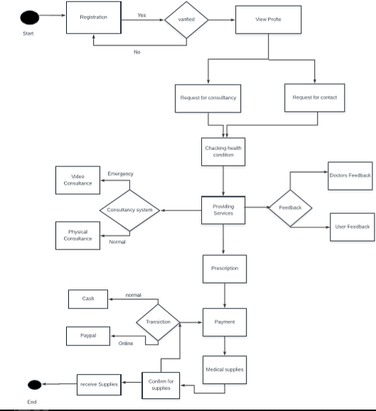

Figure : Activity Diagram

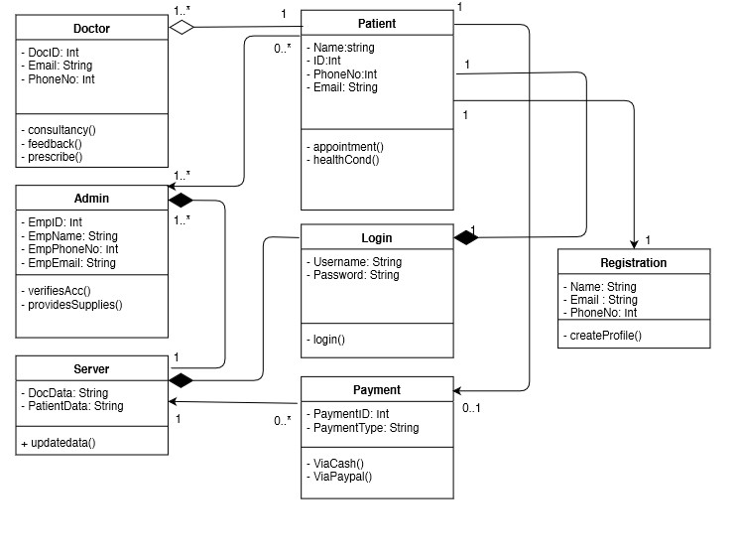

Figure : Class Diagram

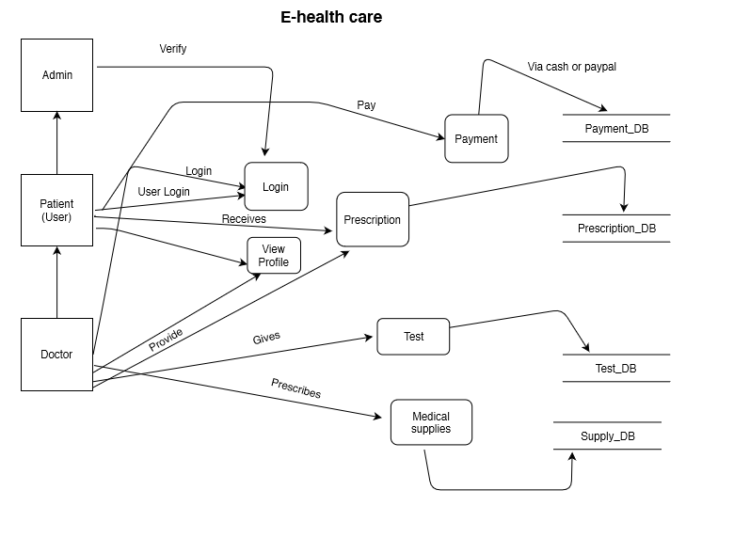

Figure : Data Flow Diagram

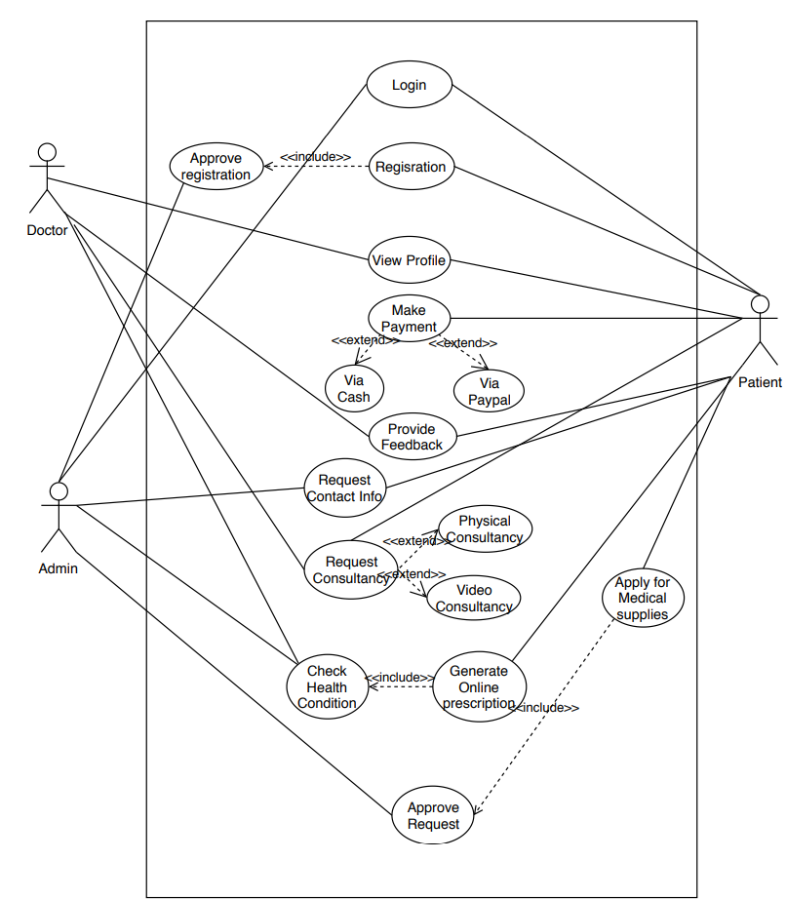

Figure : Use Case

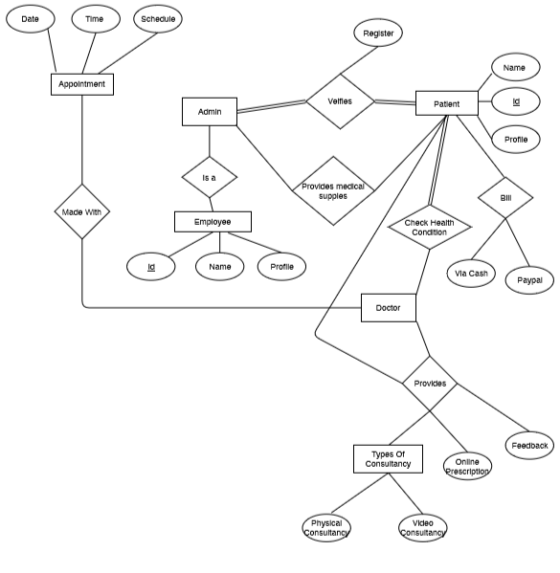

Figure : E-R Diagram

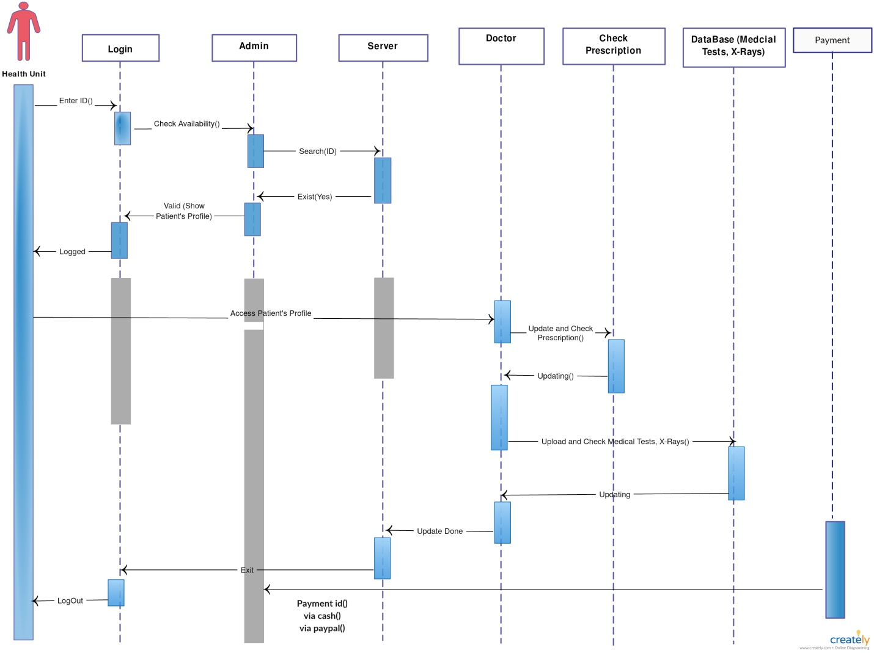

Figure : Sequence Diagram

# Test Plan

The purpose of testing is to discover errors. Testing is the process of trying to discover every conceivable fault or weakness in a work product. It provides a way to check the functionality of components, sub-assemblies, assemblies and/or a finished product. It is the process of exercising software with the intent of ensuring that the Software system meets its requirements and user expectations and does not fail in an unacceptable manner. There are various types of test. Each test type addresses a specific testing requirement.

Test objectives:

* All field entries must work properly.
* Pages must be activated from the identified link.
* The entry screen, messages and responses must not be delayed.
* Features to be tested.
* Verify that the entries are of the correct format.
* No duplicate entries should be allowed.
* All links should take the user to the correct page.

## Types of testing

Unit testing:

Unit testing involves the design of test cases that validate that the internal program logic is functioning properly, and that program inputs produce valid outputs. All decision branches and internal code flow should be validated. It is the testing of individual software units of the application. It is done after the completion of an individual unit before integration. This is a structural testing, that relies on knowledge of its construction and is invasive. Unit tests perform basic tests at component level and test a specific business process, application, and/or system configuration. Unit tests ensure that each unique path of a business process performs accurately to the documented specifications and contains clearly defined inputs and expected results.

Integration testing:

Integration tests are designed to test integrated software components to determine if they actually run as one program. Integration tests demonstrate that although the components were individually satisfaction, as shown by successfully unit testing, the combination of components is correct and consistent. Integration testing is specifically aimed at exposing the problems that arise from the combination of components.

Functional test:

Functional tests provide systematic demonstrations that functions tested are available as specified by the business and technical requirements, system documentation, and user manuals. Functional testing is centered on the following items:

Valid Input: identified classes of valid input must be accepted.

Invalid Input: identified classes of invalid input must be rejected.

Functions: identified functions must be exercised.

Output: identified classes of application outputs must be exercised.

Systems/Procedures: interfacing systems or procedures must be invoked.

System Test:

System testing ensures that the entire integrated software system meets requirements. It tests a configuration to ensure known and predictable results. An example of system testing is the configuration-oriented system integration test. System testing is based on process descriptions and flows, emphasizing pre-driven process links and integration points.

White Box Testing:

White Box Testing is a testing in which the software tester has knowledge of the inner workings, structure and language of the software, or at least its purpose. It is used to test areas that cannot be reached from a black box level.

Black Box Testing:

Testing the software without any knowledge of the inner workings, structure or language of the module being tested. Black box tests, as most other kinds of tests, must be written from a definitive source document, such as specification or requirements document. The test provides inputs and responds to outputs without considering how the software works.

Test strategy and approach:

Field-testing will be performed manually and functional tests will be written in detail.

Acceptance Testing:

It is a critical phase of any project and requires significant participation by the end user. It also ensures that the system meets the functional requirements.

All the test cases mentioned must be passed successfully and no defects should be encountered.

# Conclusion

The project E-Health Care System is for computerizing the communication between a doctor and a patient. It is a great improvement over the manual system. The computerization of the system has speed up the process. The current system is very slow. Although it seems like a cost effective, quick and efficient process, the E-Health Care System must be thoroughly tested and checked if it is reliable. The software takes care of all the requirements of an average patient and is capable to provide easy and effective storage of information related to patients that come up to the doctor. It generates test reports and provides the facility to the doctors for searching the details of patients. It also provides billing facility for the patient and allows the doctor to update and check the patient’s health status information. The system also provides the facility of backup in a backup server as per the requirement.

This service has created opportunity to get medical advice for rich or poor people living particularly in rural areas. Medical advice now may be instantly available no matter whether it is late night, an acute health problem or long distance from hospital. For conditions where patients do not need to come to hospital, they can do so by taking advice through mobile phone.  There is no need of coming to sub-district or district hospitals for those treatments, which are possible from village community clinics. The service helps citizens avoid informal healers that may lead them to complications of diseases.